**Day Trading Secrets You MUST KNOW. Strategy number one. Steps**

1. Find a level of resistance or support that's been tested multiple times as resistance or support on a 4-hour chart.
2. On the 4-hour chart, wait for the market to back up and gets close to that level that has been tested multiple times on the 4 hour chart.
3. Create a zone from beginning of the wick to the end of the wick in that **area that’s been tested multiple times.**
4. Go down to the 5 -minute time-frame.

Conditions.

1. Wait for the market to run into our zone of major structural resistance
2. Wait for the one, two, three move out of our marked zone, now we're in a downtrend on a very low time frame structural resistance on a higher time frame.

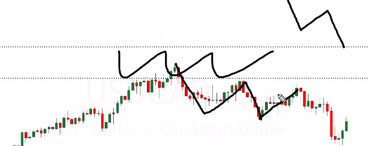

1. After breaking this support one more time this is when to start looking for possible selling opportunities and that selling opportunity came with 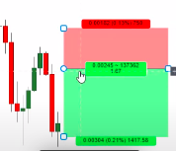selling pressure.

NOTE: This level is the **resistance or support that's been tested multiple times as resistance or support on a 4-hour chart.**

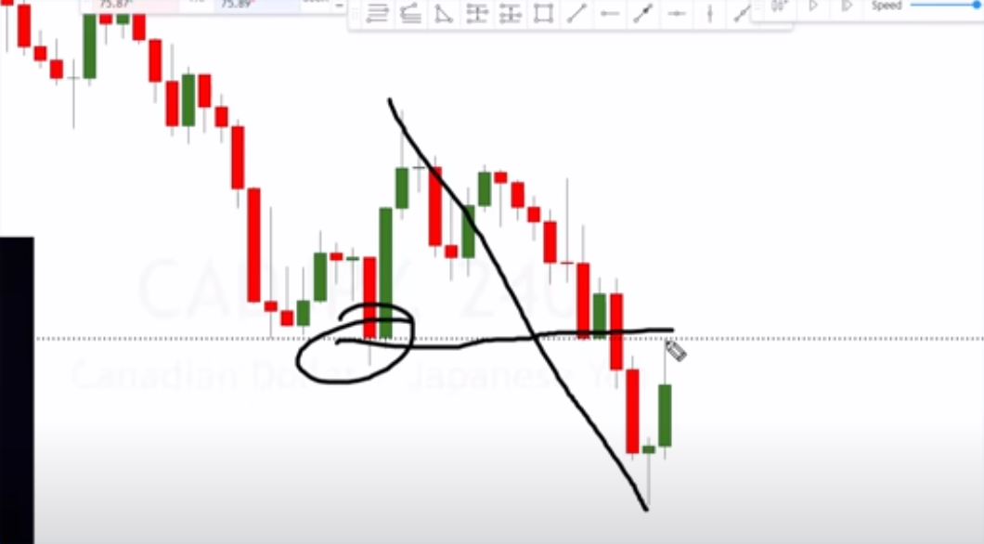

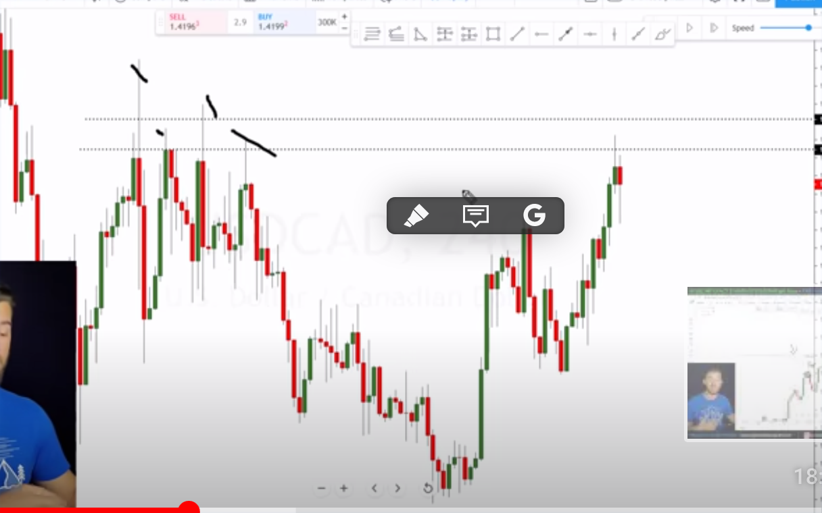

Strategy number 2. **EURAUD. Looking for a swap level of structure.**

The second way of looking for possible entries is looking for a swap level.

This is a level of structure that's been resistant and support all at the same time with some selling pressure on a 4 hour chart.

**Steps:**

1. Look for **a major level of structural resistance** on a 4 hour chart
2. M**arket doesn't have to hit that level multiple times,** we do need it to be a **major level** on a 4 hour chart
3. When the market gets back up to that **major level of structural resistance** level, this is the time that we're looking for possible day trades.
4. **Go down to the 5-minute chart**

**NOTE: A major level of resistance is a level that's pushed the market around a good bit**

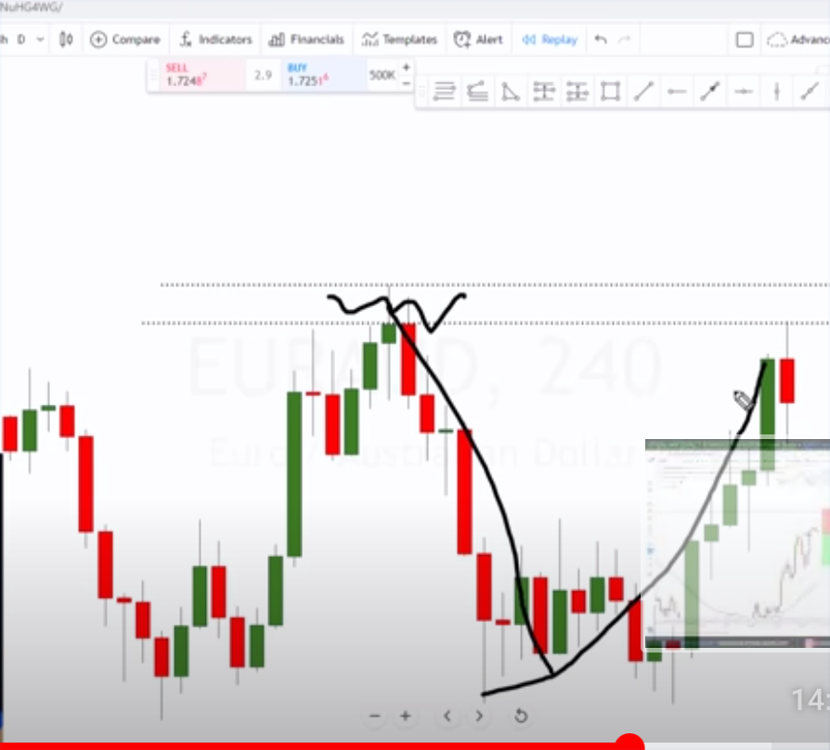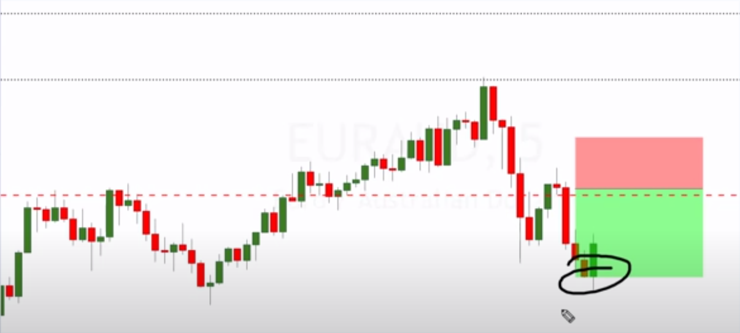

Resistance level turn support = swap level

Entry reasons:

1. The second way of looking for possible entries is looking for a swap level of structure that's been resistant and support all at the same time.
2. Look for the market to push down from the swap level with some selling pressure
3. Selling pressure occurs when the majority of the traders are selling, indicating that the majority think the market price will decrease.

Strategy number 3. CADJPY Steps.

When **a major level of support is broken**, it's highly likely that that **level** will **become resistance at least for a small amount of time.** Even if we have that as a level of resistance **just for a small amount of time on the 4-hour chart.**

**This** gives us plenty of movement and plenty of time to capture profits on a **smaller time frame** like a day trading time frame. R**emember we don't need this 4 hour chart to continue in a downtrend in order for us to hit our profits on a 5-minute chart.**

We can hit our profits quite easily with just a small amount of movement or what would look like a small amount of movement here on the 4-hour chart.

Drop down to the smaller time frame and take a look what at what the market did.

R**emember the third way of identifying structure is the previous level of major structure that was broken and when the market pulls back to that level.**



After breaking this support one more time this is when to start looking for possible selling opportunities and that selling opportunity came with selling pressure.

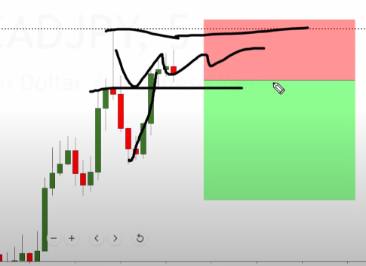NOTE: The black dotted line that you see on the chart is that **level of previous support** turned to resistance on the **4 hour chart**. At this level, we got a long wick to the top side meaning tons of selling pressure